**Django is a web framework for Python that includes built-in support for serialization.**

**Serializers in Django**

**Serializers** in Django help with converting complex data into a simple format that can be easily transmitted and stored. They offer several benefits such as validation, data conversion, and customization.

Django offers two types of serializers:

1. **ModelSerializer**
2. **Serializer**

***ModelSerializer*** is used for serializing Django models. It automatically creates a serializer class based on the model fields. This makes it easy to serialize and deserialize model instances.

***Serializer*** is a more generic serializer that can be used for any type of data. It provides more customization options, but also requires more manual configuration.

**Serializing data in Django**

Serializing data in Django involves converting complex data into a simple format, such as JSON or XML. This can be done using Django’s built-in serializers.

For example, let’s say you have a Django model called “Book” that has fields such as “title”, “author”, and “published_date”.

You can use a ModelSerializer to serialize the Book instance into JSON format:

from django.core import serializers  
from myapp.models import Book

book = Book.objects.get(pk=1)  
data = serializers.serialize('json', [book,])

This will generate JSON data that looks like this:

[  
 {  
 "model": "myapp.book",  
 "pk": 1,  
 "fields": {  
 "title": "The Great Gatsby",  
 "author": "F. Scott Fitzgerald",  
 "published_date": "1925-04-10"  
 }  
 }  
]

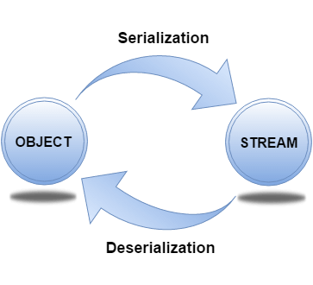

**Deserializing data in Django**

Deserializing data in Django involves converting simple data, such as **JSON or XML**, back into complex data. This can also be done using Django’s built-in serializers.

For example, let’s say you have JSON data that represents a Book instance:

{  
 "model": "myapp.book",  
 "pk": 1,  
 "fields": {  
 "title": "The Great Gatsby",  
 "author": "F. Scott Fitzgerald",  
 "published_date": "1925-04-10"  
 }  
}

You can use a Serializer to convert it back into a Django model:

from django.core import serializers  
from myapp.models import Book

json_data = '{"model": "myapp.book", "pk": 1, "fields": {"title": "The Great Gatsby", "author": "F. Scott Fitzgerald", "published_date": "1925-04-10"}}'  
  
book = list(serializers.deserialize('json', json_data, ignorenonexistent=True))

print(book.object)

print(book.object.name)

from django.core import serializers  
  
d = serializers.serialize('json', Order.objects.all())

for obj in serializers.deserialize('json', d):

print(obj.object)

This will create a Book instance with the data from the JSON string.

Custom serialization in Django Django also allows for custom serialization, which means you can define your own serialization rules. This can be useful when you need to serialize data in a way that isn’t supported by Django’s built-in serializers.

For example, let’s say you have a Django model called “**Person**” that has a field called “**name**“ and a related model called “**Address**” that has fields for “**street**”, “**city**”, and “**state**”. You want to serialize the Person instance along with their address, but you want the address to be nested inside the Person object.

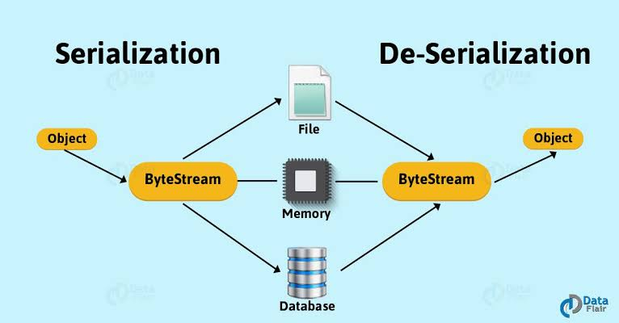

**Limitations and considerations**

While serialization is a powerful tool in web development, there are some limitations and considerations to keep in mind when using it in Django.

One limitation is that serialization can be computationally **expensive, especially for large amounts of data.** This can impact performance, so it’s important to use serialization judiciously and optimize it as much as possible.

Another consideration is **security**. Serialization can potentially **expose sensitive** data if not used correctly, so it’s important **to take precautions** such as using secure communication protocols and validating user input.

**Conclusion**

Serialization is a critical component of web development, and Django provides powerful tools for **serializing and deserializing** data. By using Django’s built-in serializers or creating custom serializers, you can **easily convert complex data into a format that can be easily transmitted** and stored. However, it’s important to keep in mind the limitations and considerations of serialization to ensure that your Django application is secure and performs well.